Rmarkdown Activity Walk Through

Open up Rstudio from My Services.

A window should appear that looks like this:

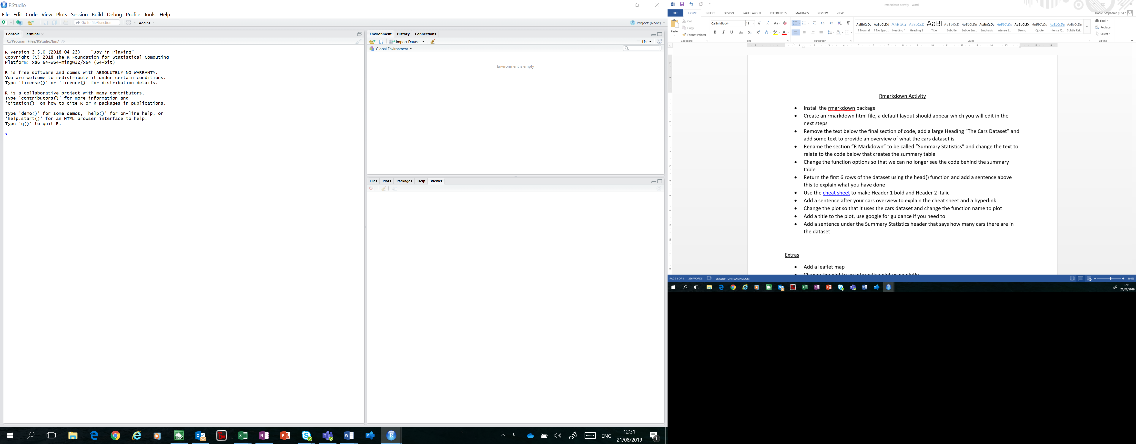

* **Install the rmarkdown package**

Install the rmarkdown package using install.packages(), this might take a few seconds.

Call the package to your R session by using the library() statement.

Your screen should now look like this.

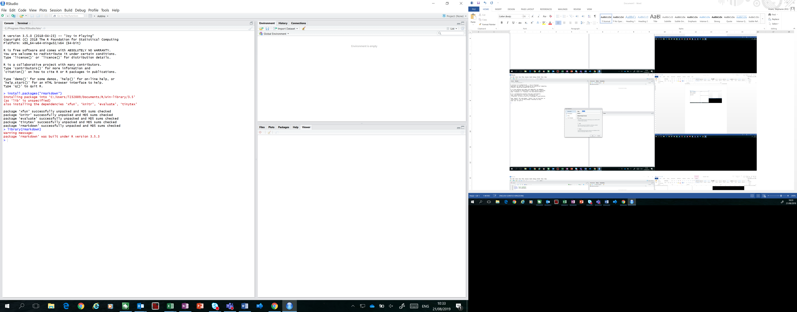

* **Create an rmarkdown html file, a default layout should appear which you will edit in the next steps**

Make a new rmarkdown file as follows:

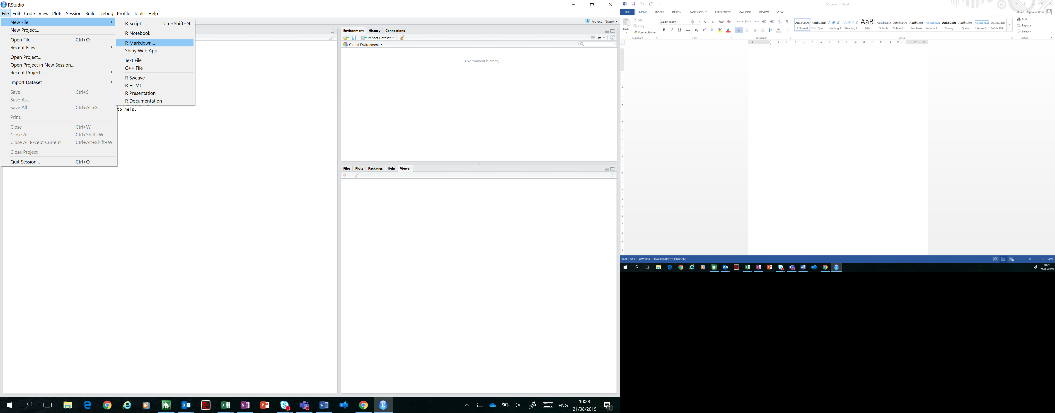

Rename the rmarkdown from the default to whatever you like.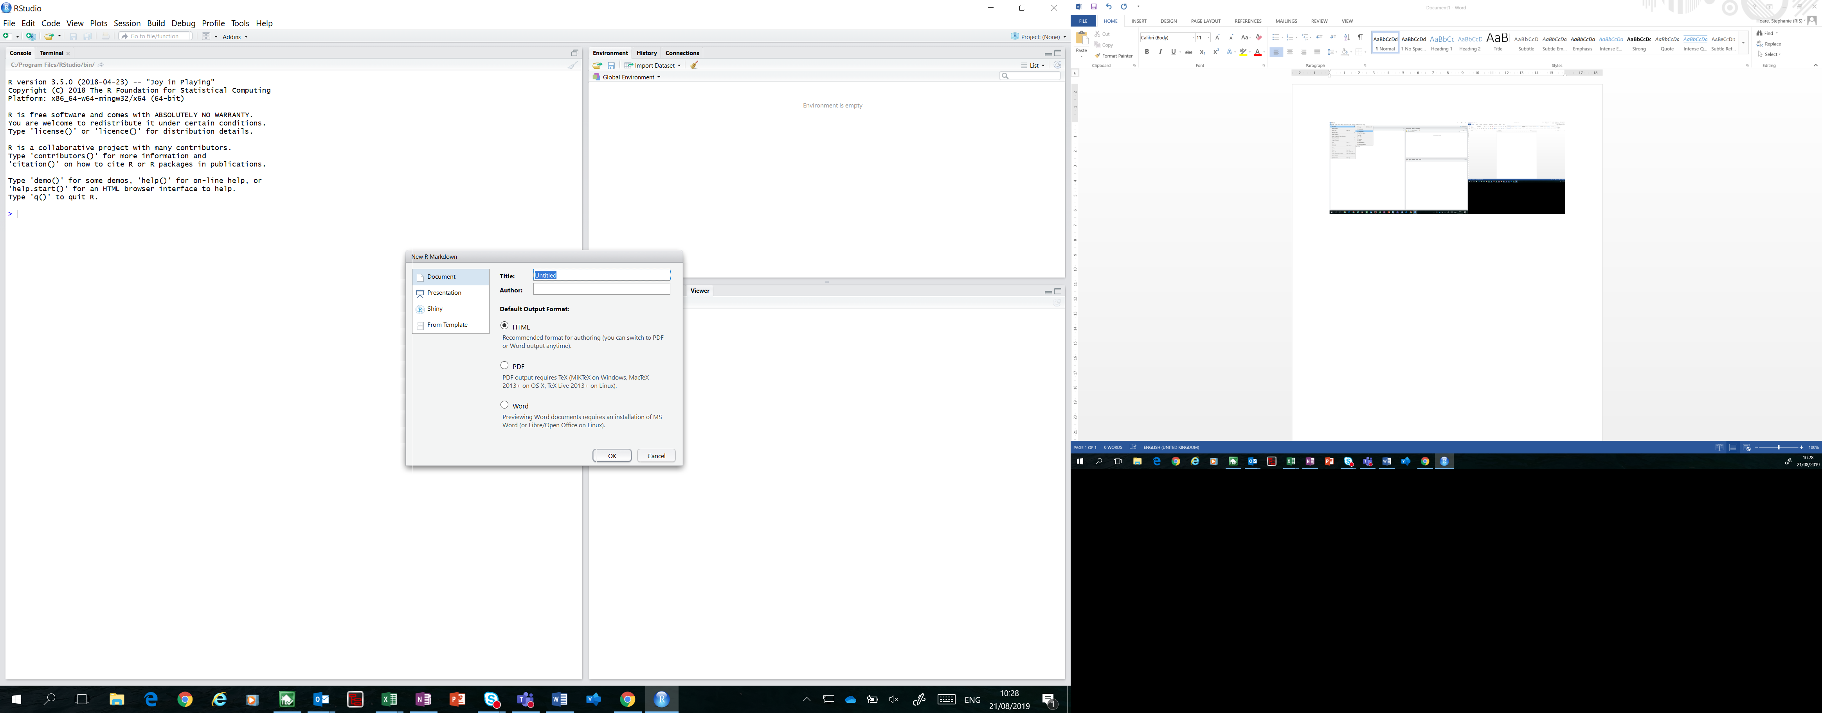

Change no other options and the following default should appear when you click ok.

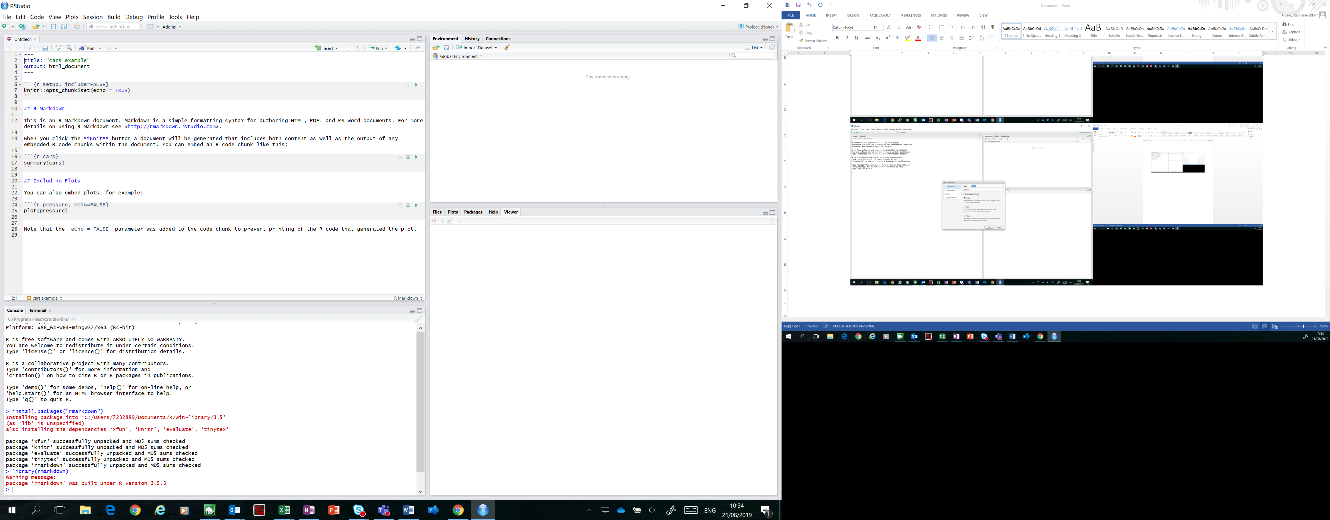

This layout tells you how rmarkdown works.

Press knit and decide where to save the html output. Read the html document and examine how the format in R has produced the html file. The title you created is shown at the top of the page and the output is a html document as stated at the beginning of the script.

Each section of code is separated by:

```{r, *name of code*}

*Code*

```

Extra functions can be used within the calling of the code to customise it, for example echo=FALSE as explained in the text below the plot.

Each subtitle is created using #. The number of #’s used specifies the size of title you are using, as explained in this [cheat sheet](https://www.rstudio.com/wp-content/uploads/2015/02/rmarkdown-cheatsheet.pdf).

Text outside of the code functions will be displayed in the outputs. For example the section of text starting with “This is an R Markdown document. …”

* **Remove the text below the final section of code, add a large heading “The Cars Dataset” and add some text to provide an overview of what the cars dataset is. This** [**cheat sheet**](https://www.rstudio.com/wp-content/uploads/2015/02/rmarkdown-cheatsheet.pdf) **might help you here and throughout**

Delete the last sentence at bottom of the code that starts “Note that the `echo = FALSE`…”.

Add a large heading using one # on a new line after the r setup code.

Add a sentence after this so that the text is displayed in the output file.

Your window should now look like this.

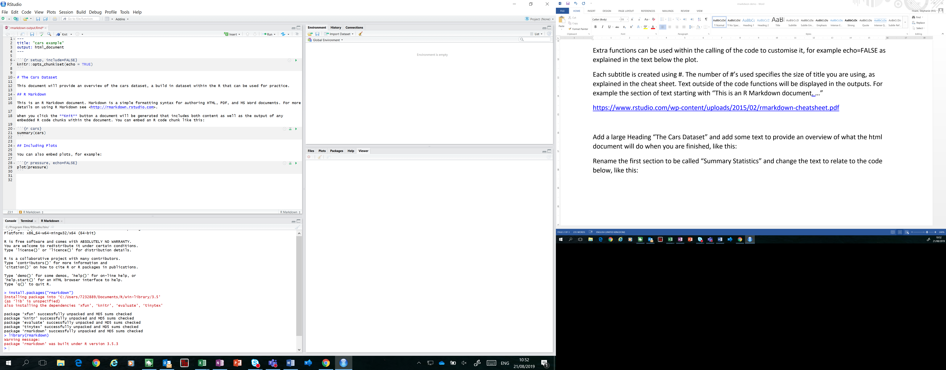

Press knit to check that this has worked.

* **Rename the section “R Markdown” to be called “Summary Statistics” and change the text to relate to the code below that creates the summary table**

Change the words after ## from R Markdown to Summary Statistics and replace the text underneath it to a new sentence about the summary table.

Your window should now look like this.

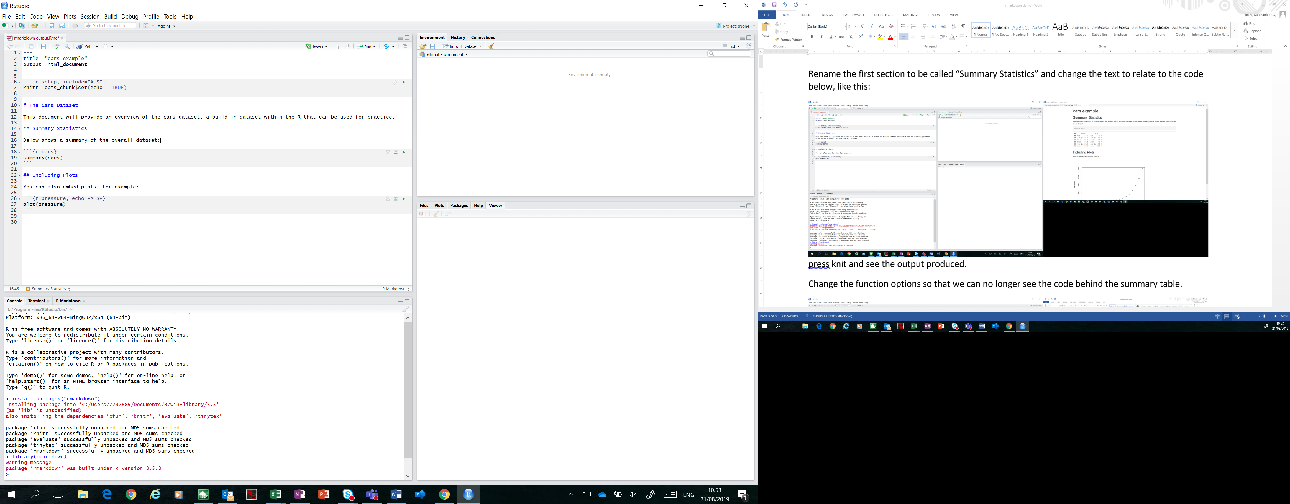

Press knit and see the output produced.

* **Change the function options so that we can no longer see the code behind the summary table**

Add echo=FALSE after the code name cars.

Your window should now look like this.

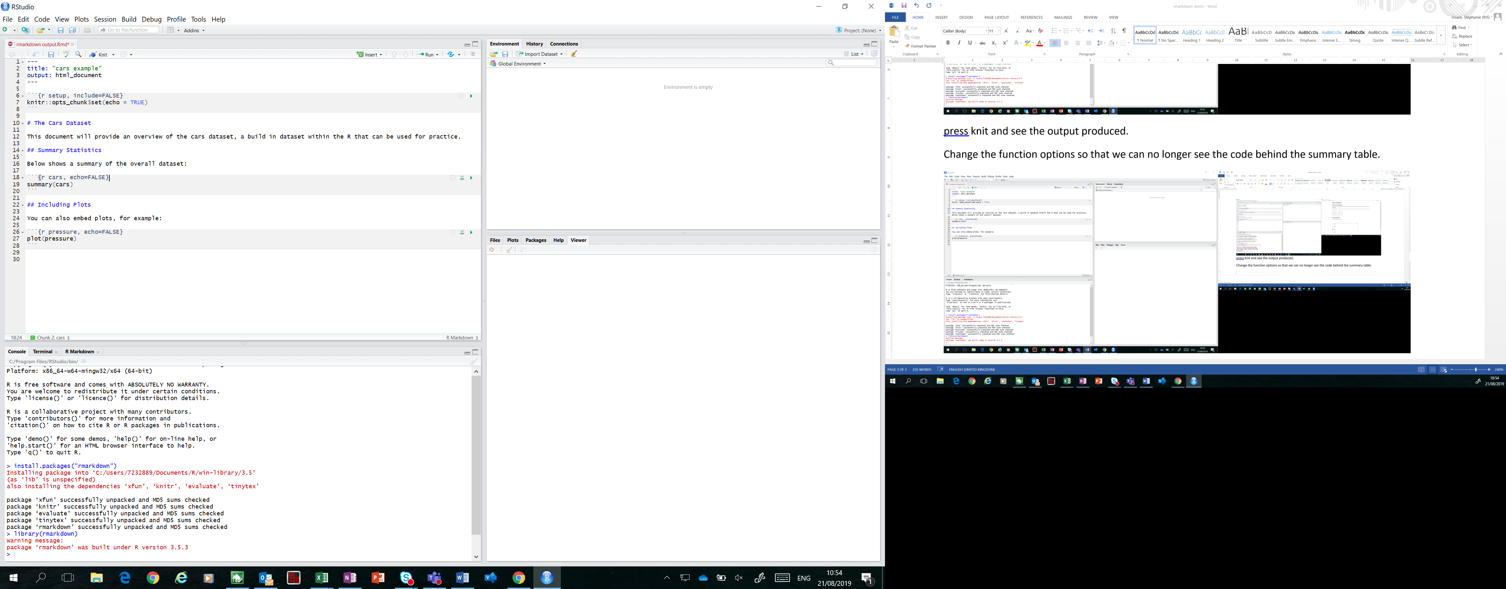

If you’d like to check that this has worked, press knit.

* **Return the first 6 rows of the dataset using the head() function and add a sentence above this to explain what you have done**

Create a new section of code using:

```{r, *name of code*}

*Code*

```

Use the call head(cars) to return the first 6 rows of data from the cars dataset.

Write a sentence of text about this code section.

Your window should now look like this.

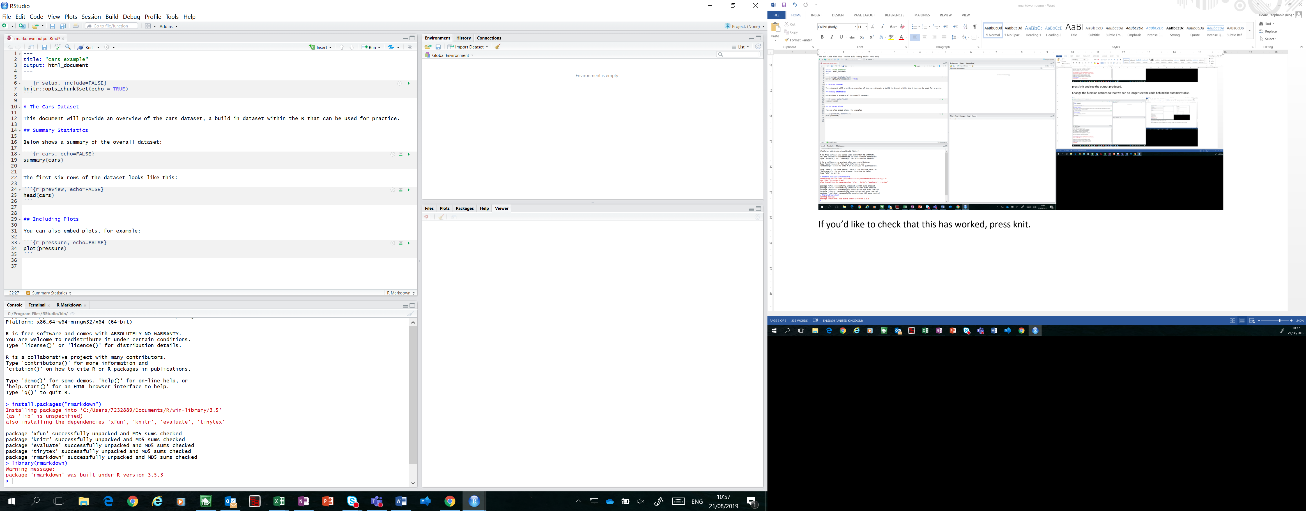

Press knit to check if this has worked.

* **Make Header 1 bold and Header 2 italic**

Use the shortcuts explained in the [cheat sheet](https://www.rstudio.com/wp-content/uploads/2015/02/rmarkdown-cheatsheet.pdf) after the #s to make the titles bold and italic.

Your window should now look like this.

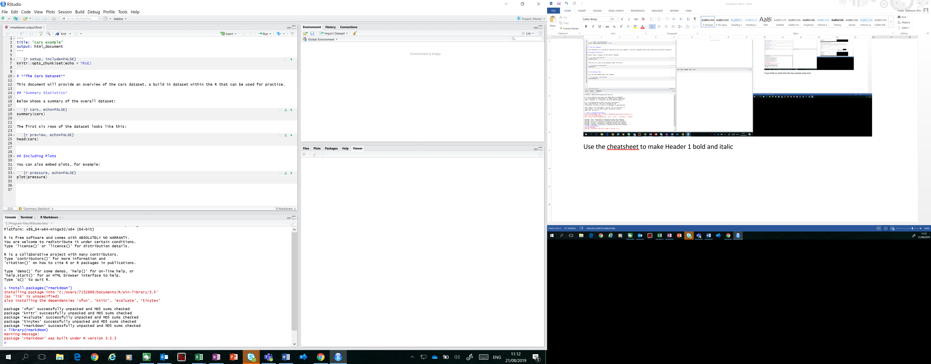

Press knit to check if this has worked.

* **Add a sentence after your cars overview to explain the cheat sheet and add a hyperlink**

Type a new sentence after the cars overview you created in step 3.

Add a hyperlink to the cheat sheet using <*hyperlink*>.

Your window should now look like this.

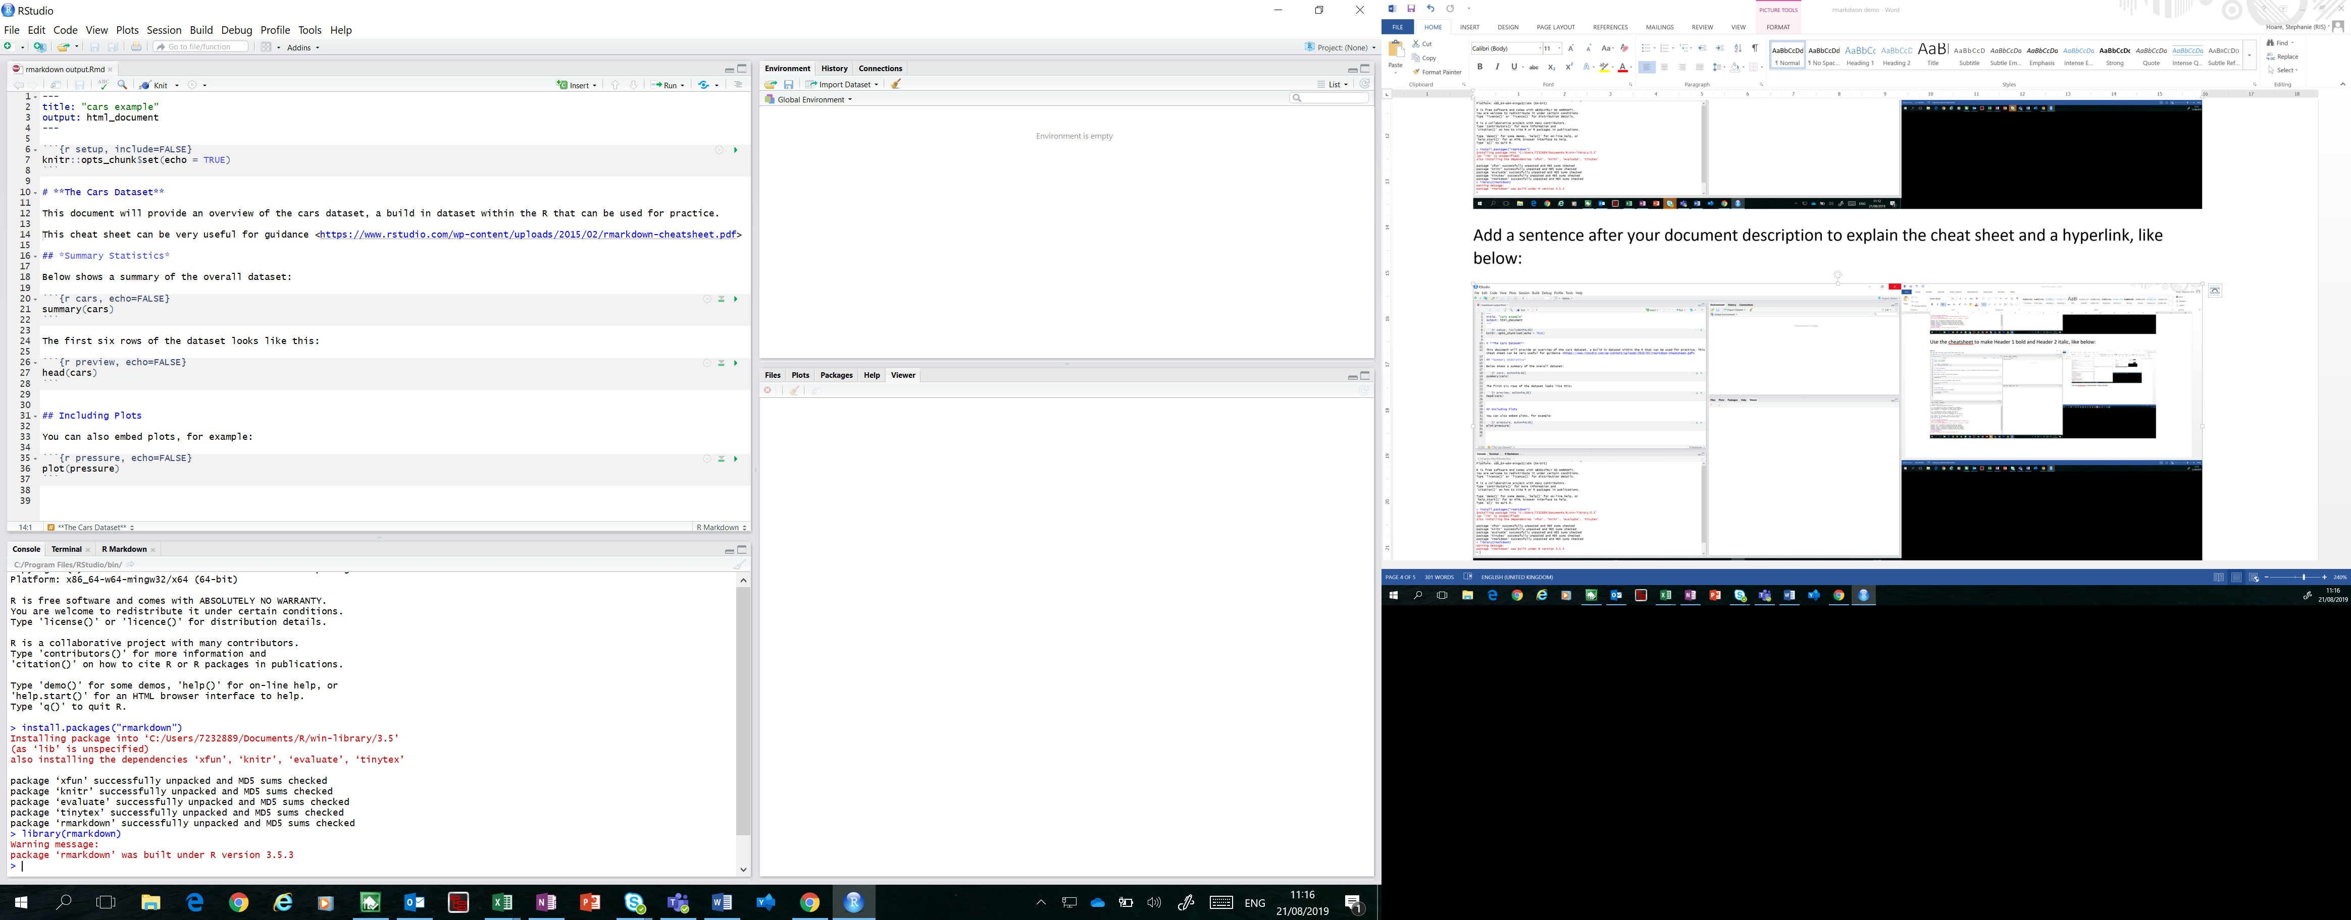

Press knit to check that this has worked.

* **Change the plot to plot the cars dataset and change the function name to plot**

Change the code from plot(pressure) to plot(cars).

Change the name of the code to plot instead of pressure.

Your window should now look like this.

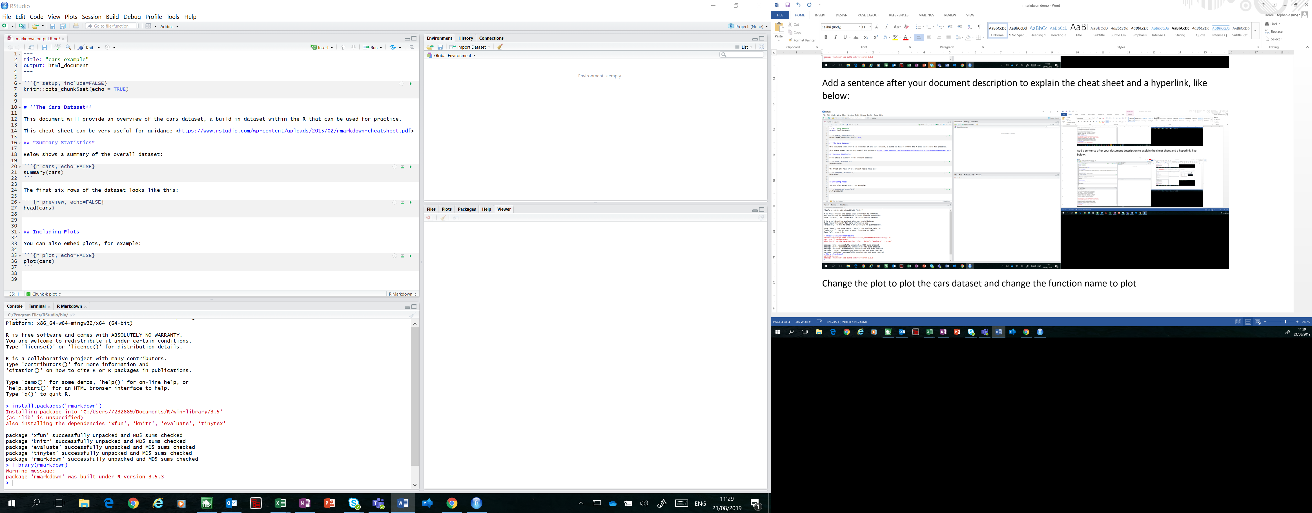

Press knit to check that this has worked.

* **Add a title to the plot**

If you’re not sure how to do this Google it, I googled “how to add a title using plot in R”.

Your window should now look like this.

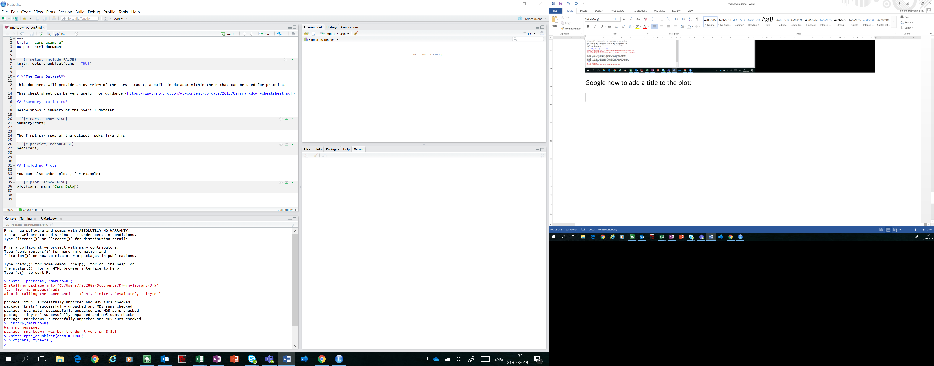

Press knit to check that this has worked.

* **Add a sentence under the Summary Statistics header that says how many cars there are in the dataset.**

This uses in line coding, again try Googling this to find out how to do it. I googled “in line coding in rmarkdown”.

The sentence calls the function no_cars to fill in the number half way through the new sentence added. No_cars is defined within the first section of code, r setup.

R setup is a good place to put code that you need throughout but you don’t want to show in your output. The include =FALSE function after setup in the name of the code means that the output will not be included in the html.

Your window should now look like this.

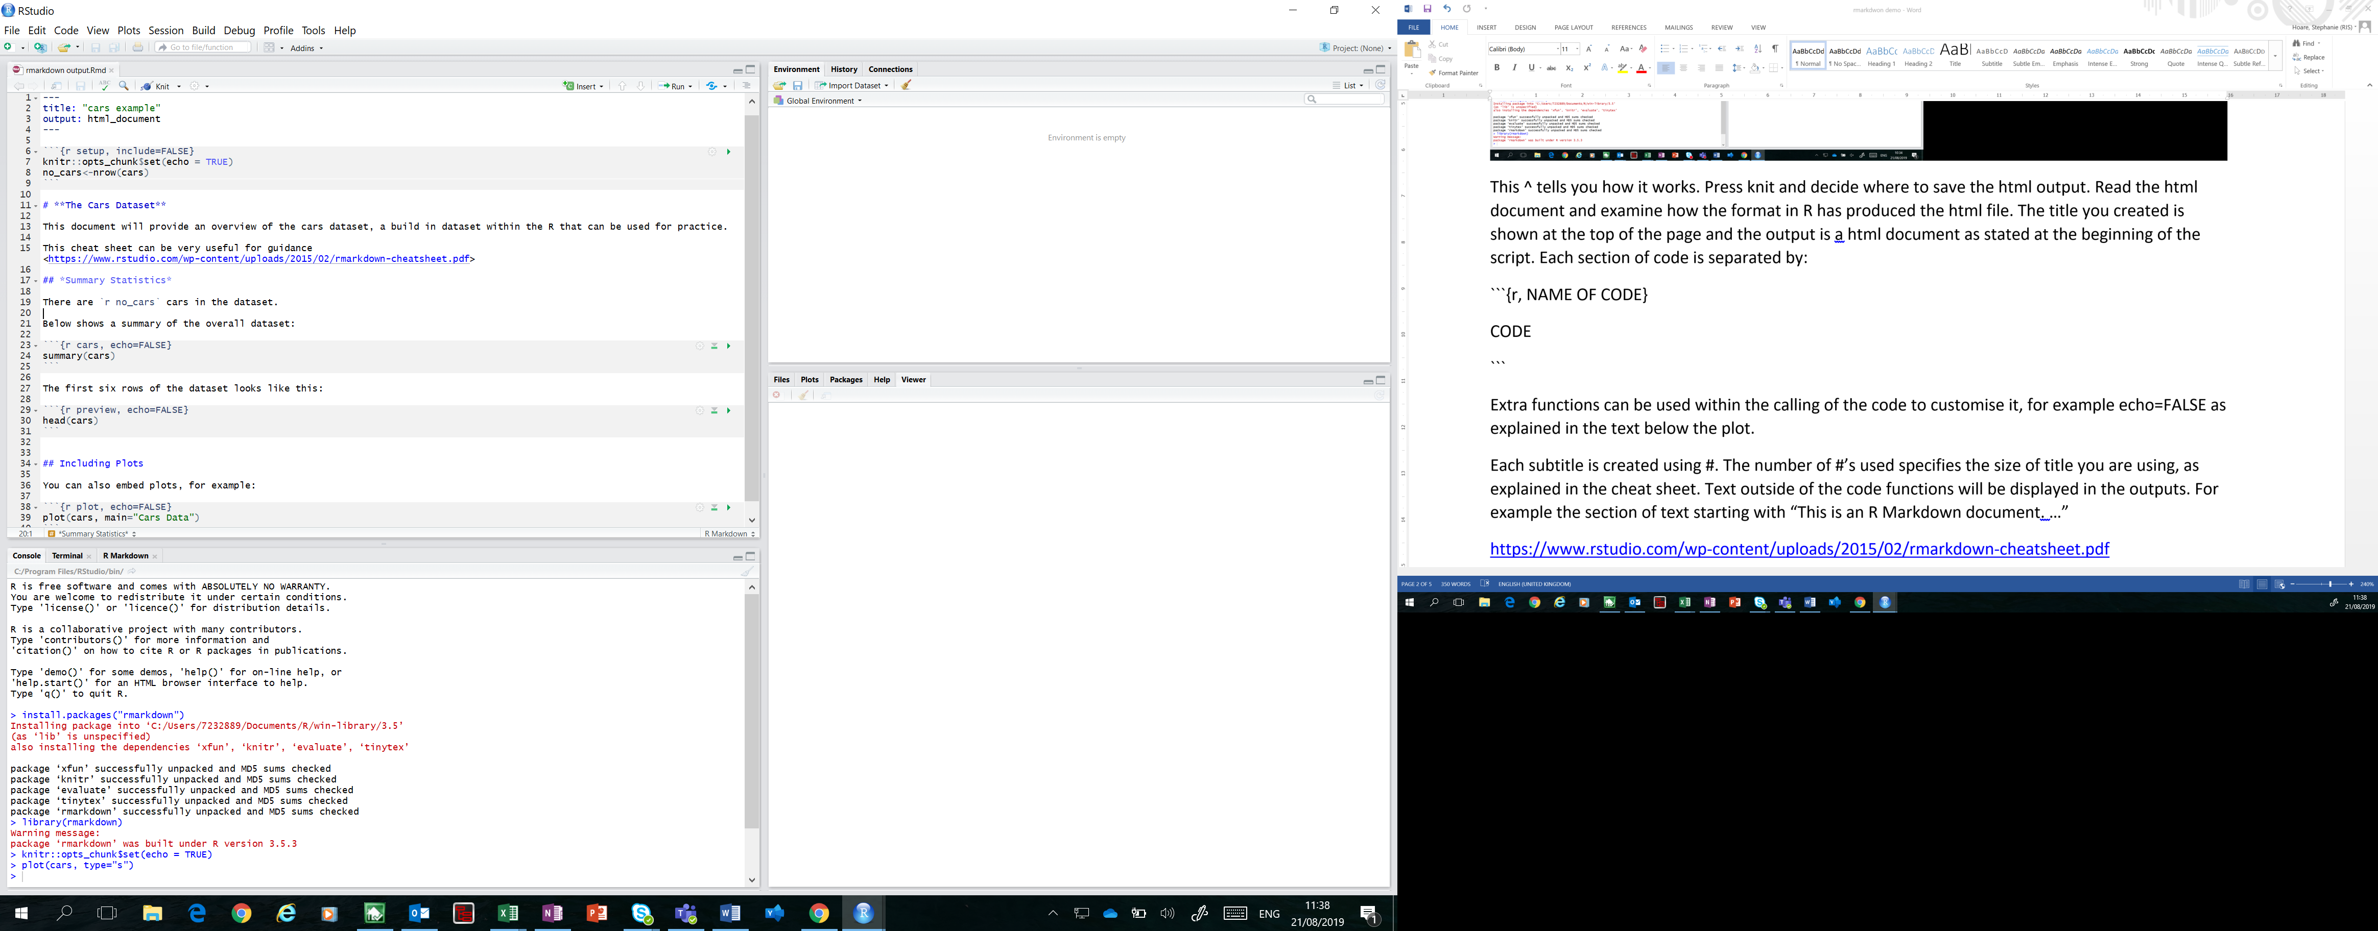

Press knit to check that this has worked.

**Extras**

* Add a leaflet map
* Change the plot to an interactive plot using plotly
* Can you think of anything else to add, maybe using another built in R dataset? If so, showcase this to the rest of the group